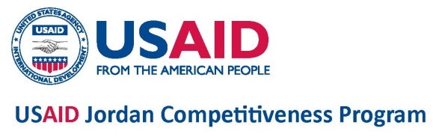

**Request for Proposal**

**(RFP) No. JCP-Amman 2017-005**

**Support the Implementation of the Jordan Investment Commission (JIC) Investment Promotion Strategy**

The USAID Jordan Competitiveness Program (JCP) is a five-year program that works with policymakers, business associations, and the private sector to draft and advocate for enabling legislation and regulation; leverage these policy interventions to stimulate exports and attract foreign direct investment, especially to Jordan's specially designated development zones; and ensure that these investments result in employment opportunities for Jordanians and, where appropriate, other residents of the Kingdom.

DAI, the implementer of USAID JCP invites specialized firms to submit proposals to provide services to support the Implementation of the Jordan Investment Commission (JIC) Investment Promotion Strategy.

To receive a full copy of the RFP, please send an email request to [jcpprocurement@dai.com](mailto:jcpprocurement@dai.com) including your contact details with RFP number in the Subject row no later than March 07, 2017. We will respond by email with a soft copy of the RFP. **The deadline for receiving proposals is March 21, 2017.**